AWS S3  For Qlik Cloud mobile mashup  - Setup Instructions | 
Using AWS S3 bucket is an excellent option to publish your mashups when you want to easily share the content with general access.
We will focus on the use case of publishing mashups for Qlik Cloud and how it gets linked with your QC Tenant.

Reuse your current AWS account
You just need an S3 bucket for this. So if you already have an AWS account it’s gonna be perfect.
In case you never signed up to AWS and create an S3 bucket, here you have some instructions:
- S3, what is it
- S3, pricing
  - The weight of stuff needed for a mashup is very thin, so it should be not cause any cost at all
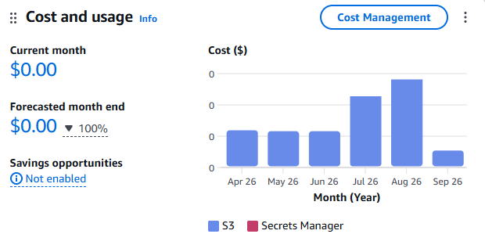
Already have an AWS Account? Let’s continue…
S3 setup
Most of the cases you will share the content, for demos, with customers, with other colleagues,…
This is the way to make everything available for public access (keep in mind only the access to the index.html will be public, you’ll decide if you want anonymous access to the data or OAuth authentication).
Just turn Block public access off in Permissions
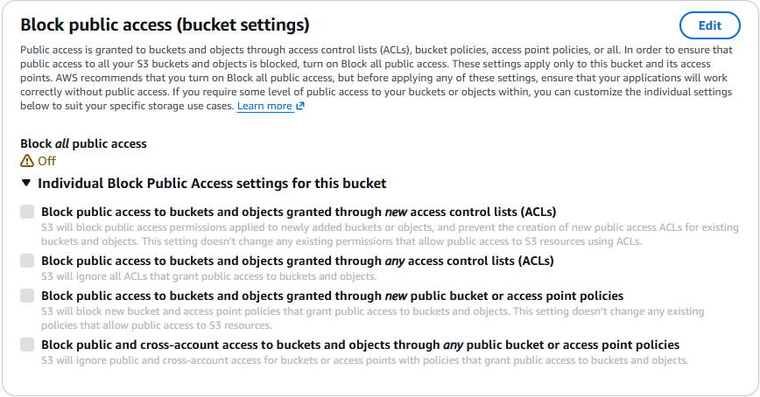

Upload and publish the mashup objects
The minimum elements you need is just a single index.html file, that can be generated with the Qlik Cloud Mashup Builder.
But to be honest, you’ll probably want to have there some stuff like, images, videos, icons,…

Try it: This is an example of mashup allocated in S3, it’s composed by 3 objects
- ‘Index.html’, this is the minimum required, the mashup with html and js code
- ‘favicon.ico’, this is optional but useful, it’s the icon that appears in your browser when you access the mashup
- ‘img’, also optional, a folder with all your images, logos, videos and other visual content you will show in your mashup to improve the look & feel
- In case you use an authenticated access, you’ll need to add another object, the oauth-callback.html file

Try it: To make all objects public
- Select all them using the check box close to column Name
- Select the combo Actions, and click on ‘Make public using ACL’

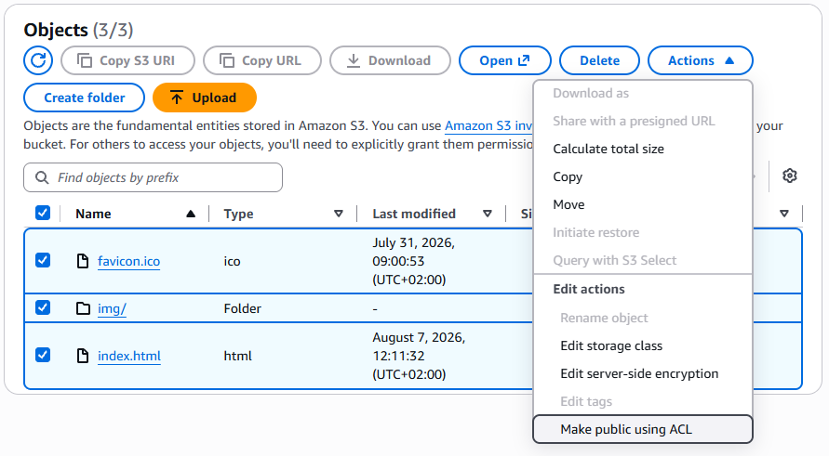
- To get the url to access to the mashup externally, click on the file index.html
- You’ll get this screen with the link

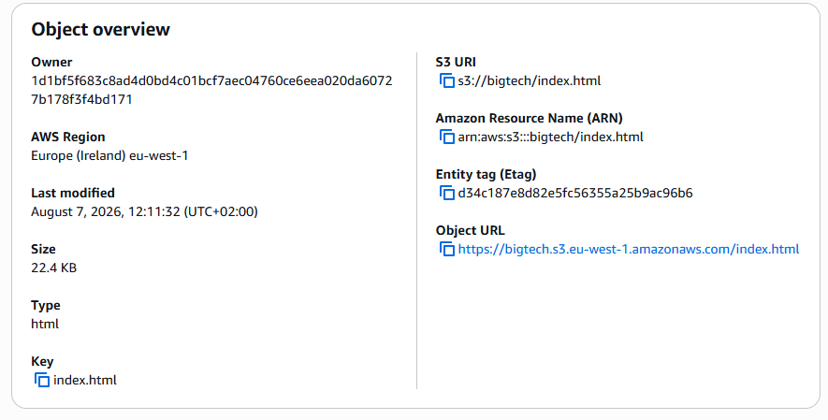

- In case you set up it for Anonymous Access, just share this link with anyone that want to test. Get the URL of the S3 bucket to be used in Qlik Cloud when configuring the oauth ClientId, in this case:
  - https://bigtech.s3.eu-west-1.amazonaws.com/index.html is the link you want to share with your colleagues to allow them using the mashup
  - https://bigtech.s3.eu-west-1.amazonaws.com this is the element you will type in Qlik Cloud admin console to set up the oauth ClientId as Allowed origin
- If the access is authenticated, the user will may be prompted to sign on (mashup builder will cause a prompt for authentication, if you want to change that for SSO please review the documentation about auth techniques for Qlik Embed)
  - https://bigtech.s3.eu-west-1.amazonaws.com/index.html is the link you want to share with your colleagues to allow them using the mashup
  - https://bigtech.s3.eu-west-1.amazonaws.com this is the element you will type in Qlik Cloud admin console to set up the oauth ClientId as Allowed origin
  - https://bigtech.s3.eu-west-1.amazonaws.com/oauth-callback.html is the element you need to type in the oauth Client Id in Qlik Cloud as Redirect URL

